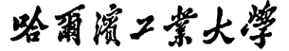


Report of Software Architecture

Homework 3.4-1: Bridge Pattern

Basic information
Team name： _______________________________
Class number: ___________________________________________________
Department/school：
Team members with student numbers：

_______________________

Instructor’s comments and score
comments：

score：
signature of the instructor：

Year month date

作业要求：Below is a design for the geometric figure volume computation.

<<interface>>
Measure
+findVolume(): double
+convert(): String

MeterMeasure
+findVolume(): double
+convert(): String
-g: GeoForm
<<interface>>
GeoForm
+computeVolume(): double
-len: double
-width: double
-height; double
Cube
+computeVolume(): double

EllipseCylinder
+computeVolume(): double

FootMeasure
-g: GeoForm

+findVolume(): double
+convert(): String

GeoVolumeGUI
-aRadius : double
-bRadius : double
-height: double

Fig 1 A design for the geometric figure volume computation using the bridge pattern

The design is based on the bridge pattern, in which the abstract part is the Measure class hierarchy, and the implementation part is the GeoForm class hierarchy. The graphical user interface is as below. A user can choose a cube or an Ellipse Cylinder from the upper left corner, then input some data for the length, width and height or long radius, short radius and height for the Ellipse Cylinder. Then click on the compute volume button to get the volume in the measure feet or meters. The resultant volume will be shown on the upper right corner of the GUI.

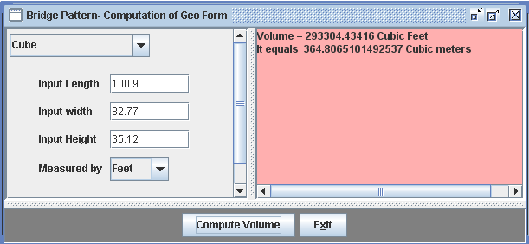
Fig 2 Graphical user interface-when user selects cube and fill out the form, chooses measured by “feet” and then click on the button “Compute volume”
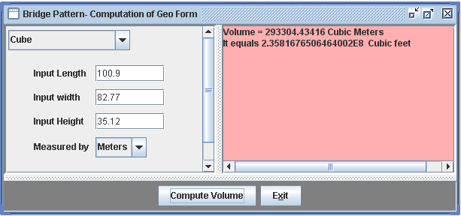

Fig 3 Graphical user interface-when user selects cube and fill out the form, chooses measured by “meters” and then click on the button “Compute volume”

Homework requirement:
- (Design) Add a new class named Ellipsoid (椭球) in the implementation hierarchy parallel to Cube and EllipseCylinder to compute the volume of an Ellipsoid
- (Implementation) Write code for the newly created class Ellipsoid
- (Implementation) Modify necessary part of the user interface class so that the user can also compute the volume of an Ellipsoid

Report part

1. Describe your finished homework, including
- What classes have been added to the existing class hierarchy?
- The relationship between the existing classes and the newly added classes.

2. Draw Your new class diagram

3. Answer questions as below: After you add class Ellipsoid,
  - Do you need to recompile class Cube?
  - Do you need to recompile class EllipseCylinder?
  - Do you need to recompile class MeterMeasure?
  - Do you need to recompile class FootMeasure?
  - Do you need to recompile class GeoVolumeGUI?

4. In class MeterMeasure, there is an constructor
public MeterMeasure (GeoForm g){
this.g = g;
}
Why do we use type GeoForm as the parameter type and why don’t we use type Cube or EllipseCylinder as the parameter type?

5. In class GeoVolumeGUI , we have the source code

GeoForm form = null;
…
if(selection.equals(CUBE) )
form = new Cube(l, w, h);
else if(selection.equals(CYLINDER) )
form = new EllipseCylinder(a, b, h);
The variable “form” is claimed as type GeoForm. Why don’t we claim it as type Cube or EllipseCylinder? What is the advantage of writing code above?

- Typical input and output from running your program

